1. An **arithmetic logic unit (ALU)** is a combinational digital electronic circuit that performs arithmetic and bitwise operations on integer binary numbers. It is a fundamental building block of many types of computing circuits, including central processing unit (CPU) of computers, floating-point units (FPUs), and graphics processing units (GPUs).

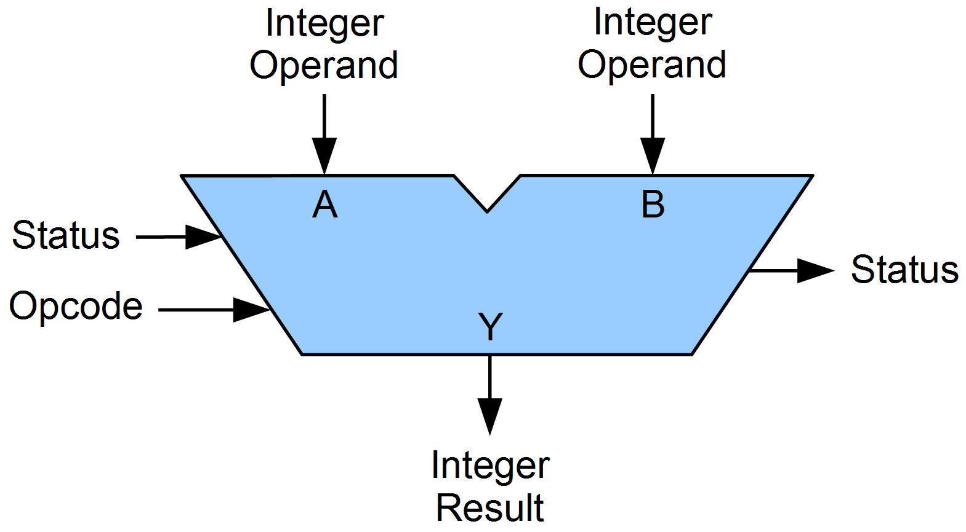

Figure 1 A symbolic representation of an ALU

An ALU have operands (data to be operated on) as the input. The result of performed operation indicated by Opcode, becomes the output. In many designs, the ALU also has status inputs or outputs, which convey information about a previous operation or the current operation.

1. A) The first chip, **74HC00; 74HCT00** is a quad 2-input NAND gate. They operate in CMOS level (74HC00) or TTL level (74HCT00), and have multiple package options.

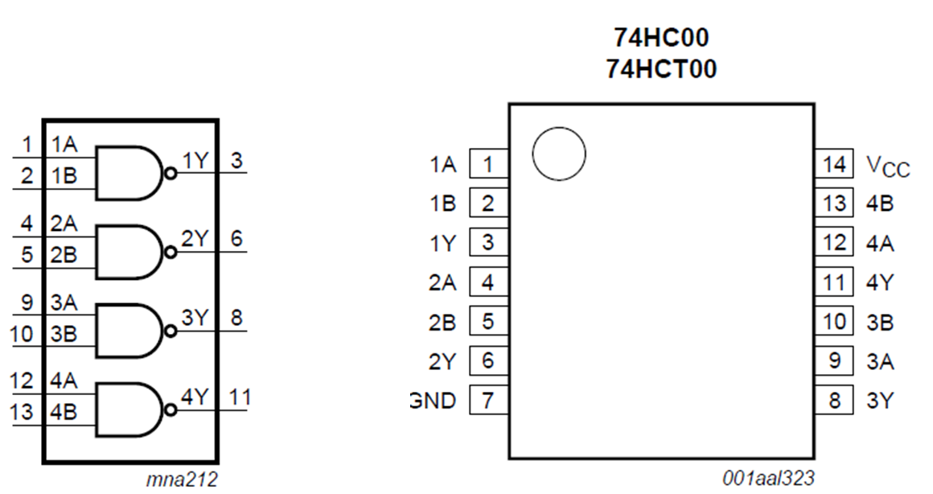

Figure 2 Functional diagram and Pin representation of 74HC00; 74HCT00

1A~4A, 1B~4B are inputs of NAND operation, and 1Y~4Y are the outputs. Pin 14 (Vcc) is connected to supply voltage, and Pin 7 (GND) is connected to ground.

NAND operation returns 0 iff two inputs are both 1. (In circuit, 0 and 1 are representation of low and high level voltage, which is below and above 0.5Vcc)

B) **74HC14; 74HCT14** is Hex Inverting Schmitt trigger. It provides six inverting buffers with Schmitt-trigger action; transform slowly changing input signals into sharply defined, jitter-free output signals.

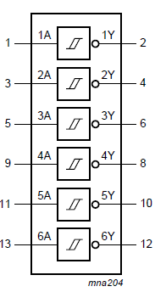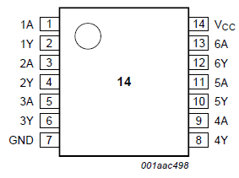

Figure 3 Functional diagram and Pin representation of 74HC14; 74HCT14

1A~6A are input, 1Y~6Y are output. GND and Vcc is same with 74HC00; 74HCT00. It is an inverter, which means input 1 returns 0 and input 0 returns 1.

C) DM74LS74A is dual positive-edge-triggered D flip-flops with preset, clear and complementary outputs. 쏟 information on the D input is accepted by the flip-flops on the positive going edge of the clock pulse. The triggering occurs ata voltage level and is not directly related to the transition time of the rising edge of the clock.

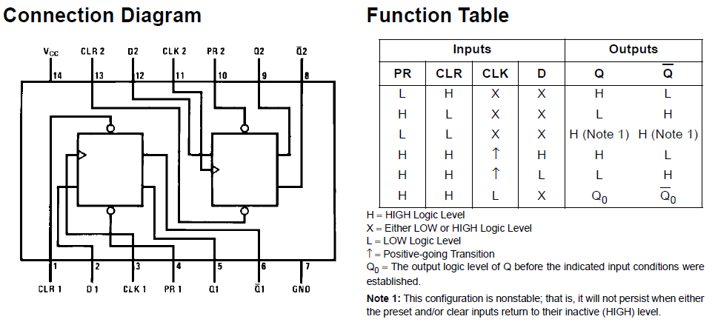

Figure 4 Connection diagram and Function table of DM74LS74

D) 74HC/HCT194 is 4-bit bidirectional universal shift register. Logic diagram, function table and pin configuration is shown as following.

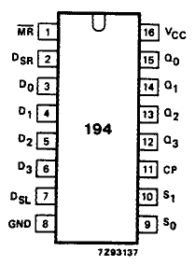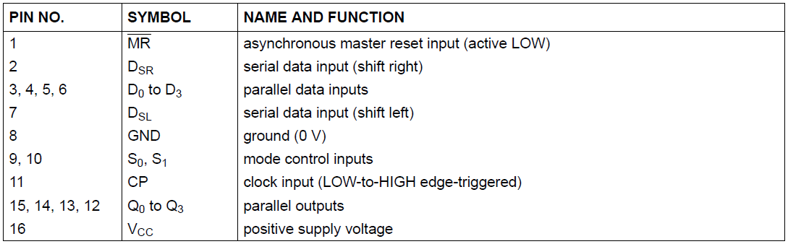

Figure 5 Pin configuration of 74HC/HCT194

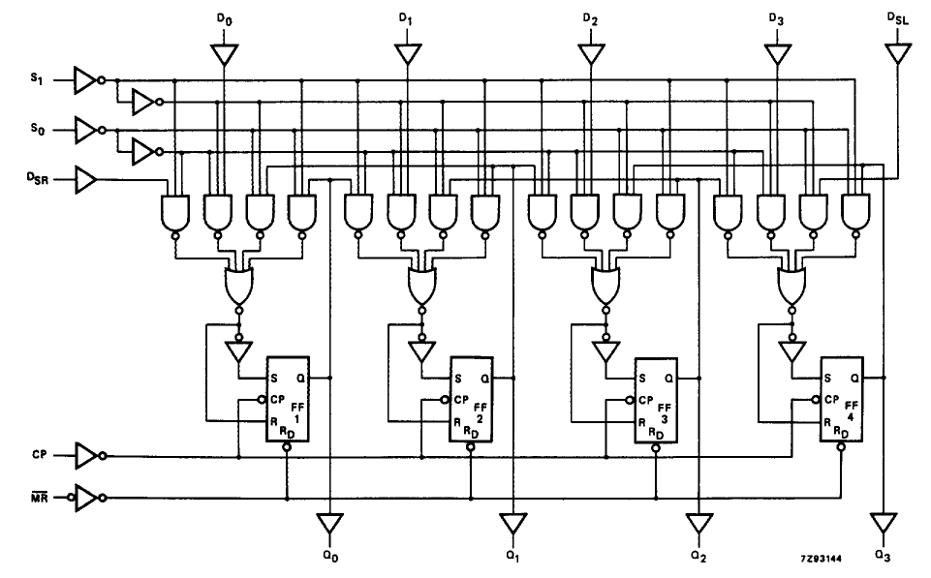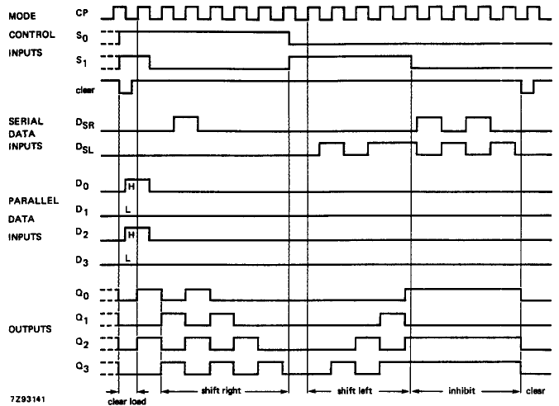

Figure 6 Logic diagram and timing sequence of 74HC/HCT194

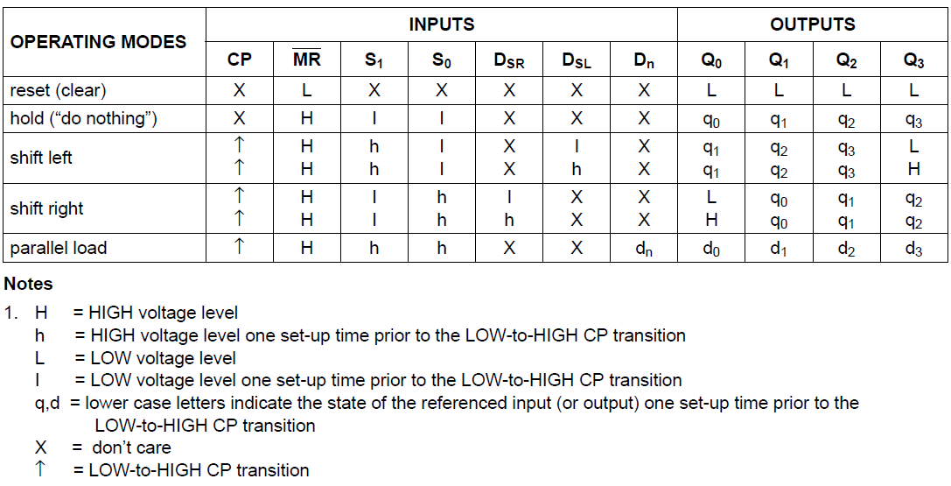

Figure 7 Function table of 74HC/HCT194

3.

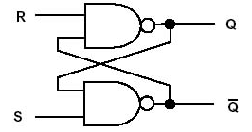

If R, S are (1,1), flip-flop circuit remains stable by taking (Q,Qbar) = (1,0) or (0,1). But if S changes to 0 even for one second, (Q,Qbar) state flips. Which means, Q remembers the slightest change of R or S. And when R changes to 0, Q returns to its initial state. This is called flip-flop.

A shift register is a cascade of flipflos, sharing the same clock, in which the output of each flip-flop is connected to the ‘data’ input of the next flip-flop in chang, resulting in a circuit that shifts by one position the ‘bit array’ stored in it, ‘shifting in’ the data present at its input and ‘shifting out’ the last bit in the array, at each transition of the clock input.s